**Content**

1. Terms 2

1. Terms

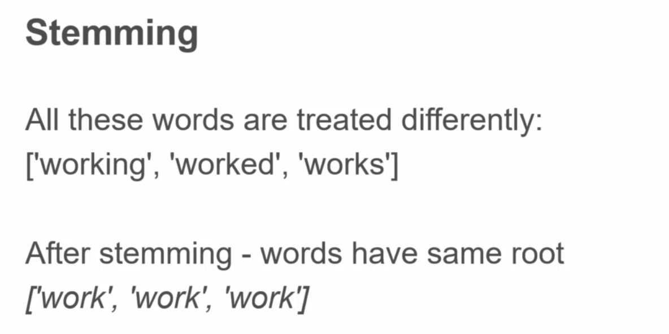

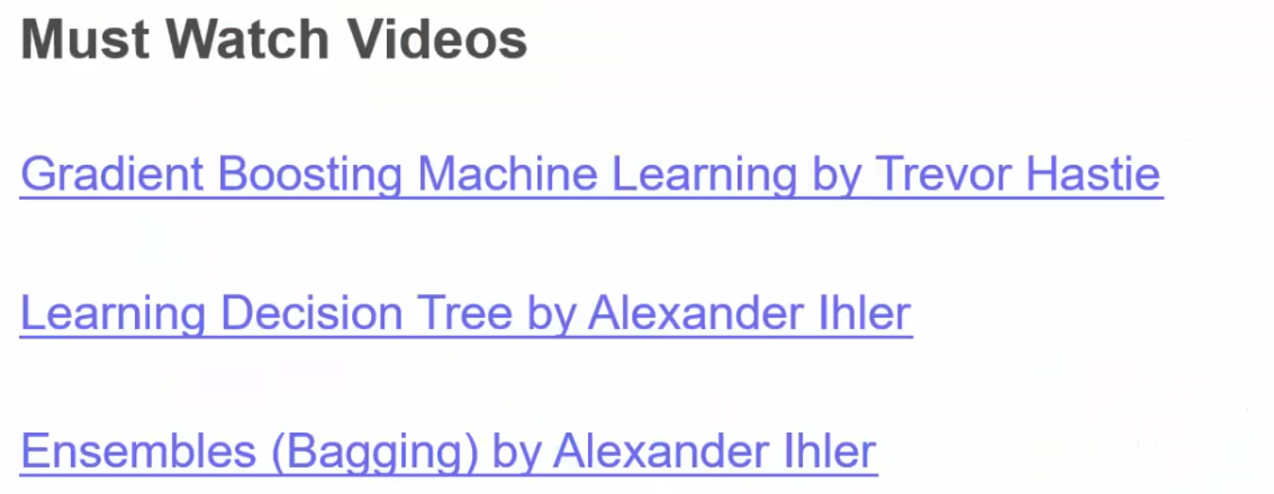

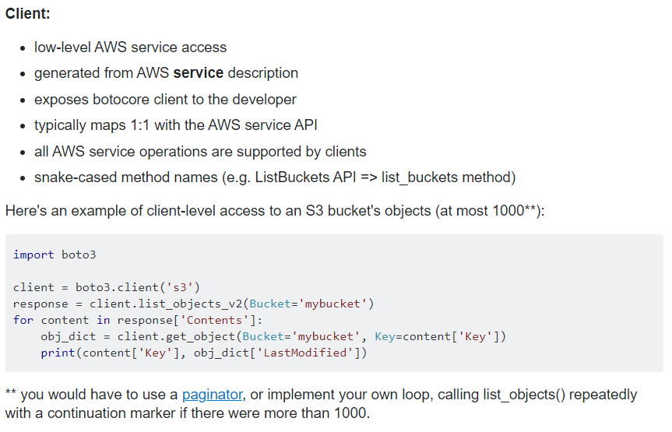

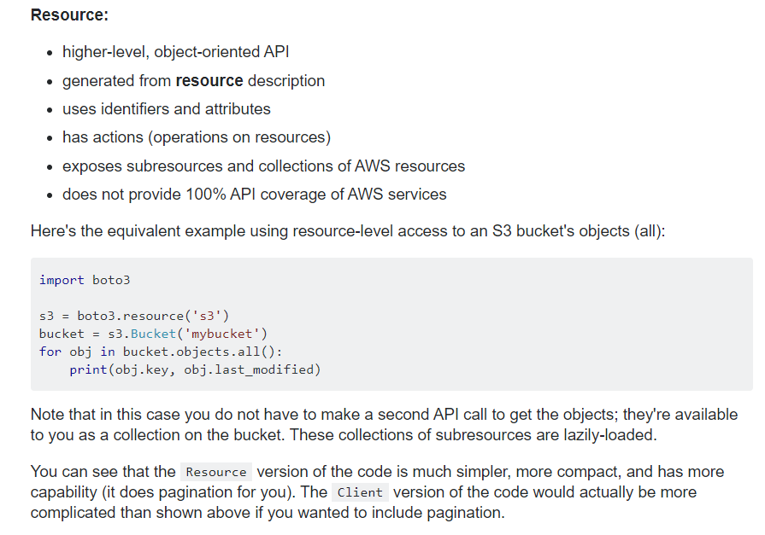

* 1. Neural Network Architectures

Node: A neural network with more than 1 hidden layer is a **Deep Neural Network**. The more hidden layers, the deeper the NN.

**Feed Forward** NN – No graphs, cycles. Connections only to the next layer to the right. **Fully connected.** (vs **Non Fully Connected, Sparse** NNs)

* + 1. Activation Functions
* **Linear**
* **Sigmoid** (S shaped curve)
* **Hyperbolic** (TANh)
* **Rectified linear unit**

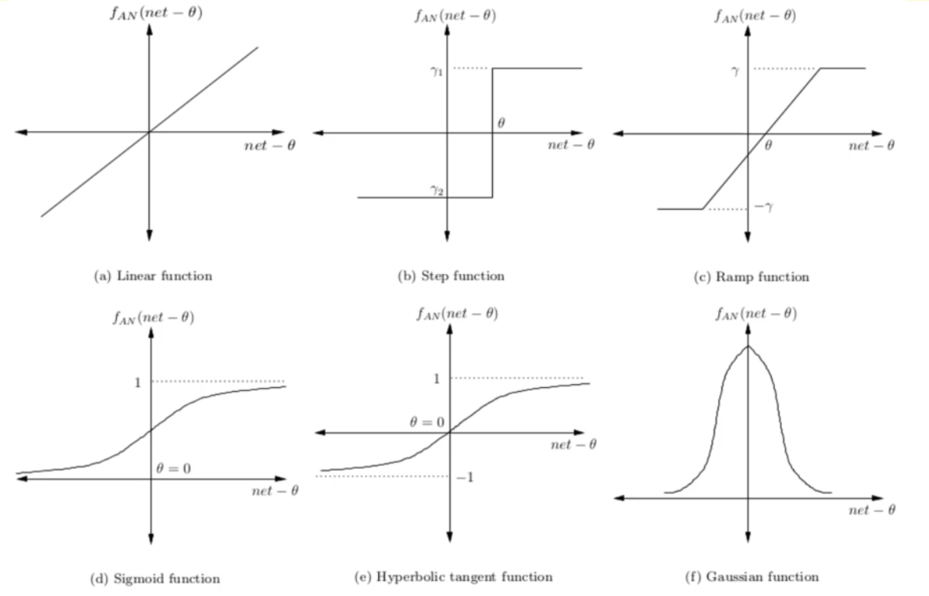

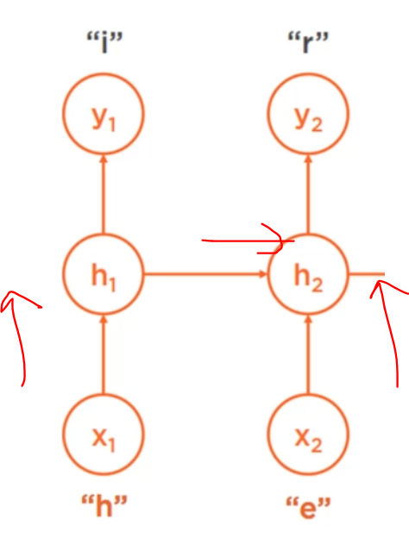**CNN – Convolutional Neural Network** – images, sparse, feed forward

**RNN – Recurrent Neural Network – feedback loops,** variable input lengths, time series, string length – NLP, Speech Recognition, Language Translation, Conversation Modelling This is like giving a NN a short term memory.

**Gated** and **LSTM** (Long Short-Term Memory)

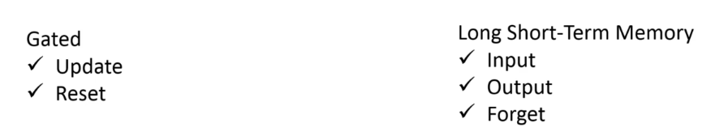

**GAN – Generative Adversarial Network**

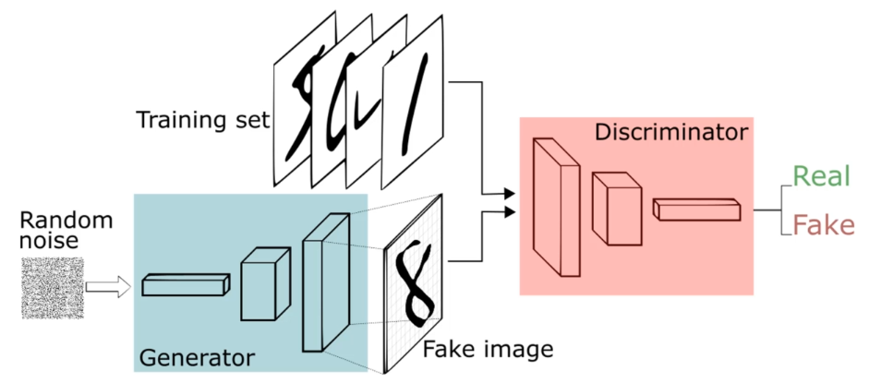

Combination of **Generator (produces fake data)** and **Discriminative (decides if fake or real) NN. Competing.**

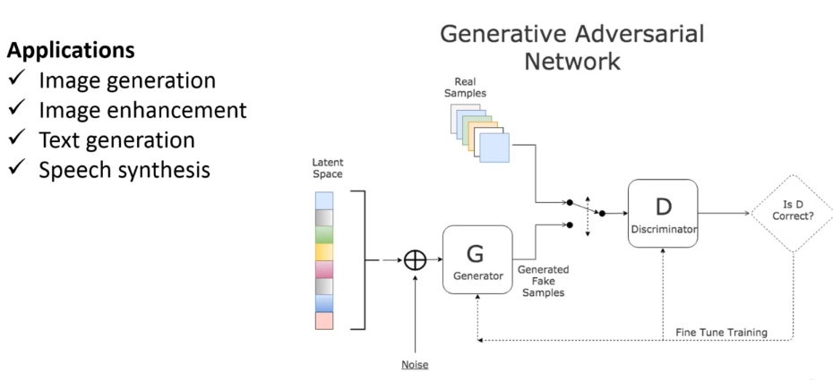

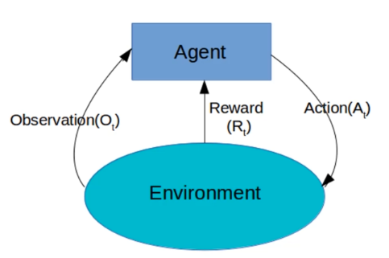**Reinforcement Learning**

**MDP (Markov Decision Process), mathematical framework for dynamic programming** and **decision making:**

*The future is independent of the past given the present*

**Hans Rosling - Gapminder**